**(Science: day of the week).**

July 20, 1973 is a FRIDAY. There is a formula to find the day of the week for a particular date. [Zeller’s](https://en.wikipedia.org/wiki/Zeller%27s_congruence)

[congruence](https://en.wikipedia.org/wiki/Zeller%27s_congruence) is an algorithm developed by Christian Zeller to calculate the day of the week. The formula is as follows:

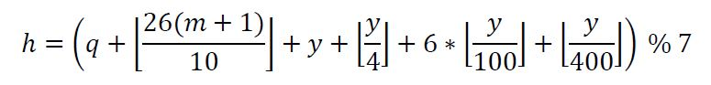

Where,

* ***h*** is the *day of the week*

(0: Saturday, 1: Sunday, 2: Monday, 3: Tuesday, 4: Wednesday, 5: Thursday, 6: Friday)

* ***q*** is the *day of the month*
* ***m*** is the *month*

(3: March, 4: April, ….., 12: December)

** *January* and *February* are counted as months *13* and *14* of the previous year

* ***y*** is the *year*

**NOTE**: In this algorithm, *January* and *February* are counted as months *13* and *14* of the *previous year*. E.g. if it is February 2, 2010, the algorithm counts the date as the second day of the fourteenth month of 2009 (02/14/2009 in DD/MM/YYYY format). **Consequently, for January and February, the year *y* should be replaced by *y – 1*. Suffice to say, the month *m* should also be replaced by *m + 12* then.**

**Task**

(*Displaying calendars*) Write a program that prompts the user to enter a year and a month of the year. It then displays the calendar table for the month of that year on the console. (10)

For example, if the user enters the year 2005, and month 2, your program should display the calendar for the February 2005, as follows:

**Sample Input/Output**

Here is an output of a sample run:

Input: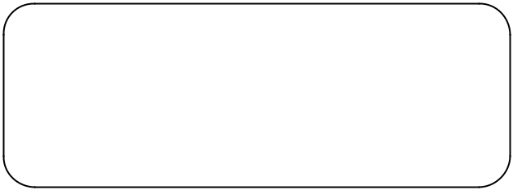

Enter year: 2005

Enter month (1-12): 2

Output:

Calendar for:

FEBRUARY 2005

SAT SUN MON TUE WED THU FRI

1 2 3 4

5 6 7 8 9 10 11

12 13 14 15 16 17 18

19 20 21 22 23 24 25

26 27 28